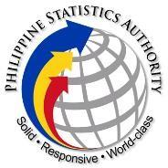

Philippine Statistics Authority

**COMMUNITY-BASED STATISTICS SERVICE**

Contract of Service Worker Accomplishment Report

|  |  |
| --- | --- |
| **FOR THE PERIOD OF:** | **March 16-31, 2022** |
| **NAME:** | **Romulo E. Curioso** |
| **POSITION:** | **Statistical Analyst** |
| **DIVISION/SERVICE:** | **CBSD/CBSS** |

|  |  |  |
| --- | --- | --- |
| **Actual Accomplishment** | | **Work Arrangement** |
| March 16, 2022   * Contract Signing & orientation | | On-Site |
| March 17-18, 2022   * Created a mini-app using VueJS Basics (8hrs) * Capitalized the use of Vue components, props, and events. (8hrs) | | On-Site |
| March 21, 2022   * Participated in 2022 Community-Based Monitoring System data Processing Flow and User Stories for the Data Processing System (6hrs) * Learned how to use VuePress (2hrs) | | On-Site |
| March 22, 2022   * Made a mini-project using VuePress (8hrs) | | On-Site |
| March 23-24, 2022   * Participated in meeting for Community-Based Monitoring System User Stories for CBMS App (16hrs) | | On-Site |
| March 25, 2022   * Learned how to create a User Interface by using Figma (8hrs) | | On-Site |
| March 28-29, 2022   * Made a UI for Form 1 and Form 4 (8hrs) * Polished the UI of Form 1 and Form 4 with the consultation of our Statistical Specialist (8hrs) | | On-Site |
| March 30-31, 2022   * Participated in Sprint Workshop for the Development of 2022 Community-Based Monitoring System (CBMS) Applications and System (16hrs) | | On-Site |
| Submitted by: | Approved by: | |
| **Romulo E. Curioso**  Contract of Service Worker CBSD | **PATRICIA ANNE R. SAN BUENAVENTURA**  Division Chief, CBSD | |

PSA Complex, East Avenue, Diliman, Quezon City, Philippines 1101 Telephone: (632) 8938-5267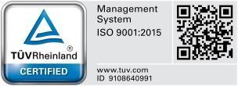

[www.psa.gov.ph](http://www.psa.gov.ph/)